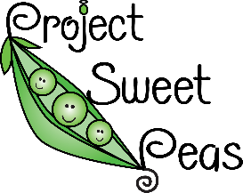
«Title» «First_Name» «Last_Name»
«Contact_Person»
«Address»
«Address_2»
«City», «State» «Zip»
Dear «Title» «Last_Name»,
As a resident of <<state or city name>>, a volunteer for non-profit organization Project Sweet Peas, and a parent who has had a baby in the neonatal intensive care unit (NICU), I am writing to ask for your help in raising awareness of a cause close to my heart, NICU Awareness Day (September 30). Along with the global community celebrating, I am determined to raise awareness.
Every parent hopes for an uncomplicated pregnancy and a healthy birth. But sometimes the unexpected happens and a baby requires neonatal intensive care. The lives of parents are turned upside down as they watch their own baby fight to live. According to the National Perinatal Association, more than half a million families experience a stay in the NICU every year. During a global pandemic that has further complicated the lives of NICU families, it is vital, now more than ever, that we acknowledge their experiences.

Could you join us in supporting these families by lighting up your building green?

We are asking buildings to light up green on September 30, NICU Awareness Day - or even for the whole month of September! However, any day in September would be brilliant for a light up and will help raise awareness. These efforts will improve the quality of life for parents of NICU babies by increasing the awareness of their experience among the public, media, government, and medical communities.
You can find out more about the campaign by visiting www,nicuawareness.org or Project Sweet Peas by visiting www.projectsweetpeas.com. If you agree to help us, I will approach our local media, as well as share the news on social media using the hashtag #NICUAwarenessMonth.

I look forward to hearing from you.

Kind regards,

